I have designed a n8n workflow to analyze the Robotframework Test automation log.html file and give the AI response on the failures.
Disadvantage of current analysis:
My project has 320 complex test cases which runs for more than 6 hours. For the Manual testers, it is difficult to analyze the full report and conclude the issue in the test cases. So I designed this workflow for the non-technical associates to get the gist of what has caused the failures.

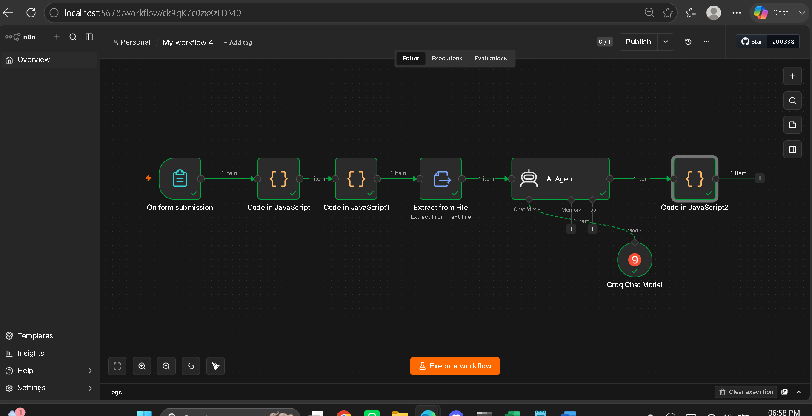

The flow contains the below nodes.
1. On form submission – to upload the latest log.html file
2. Code in Javascript(2) – to extract the failed test cases completely from the log.html and it also extracts the suite/Testcase name, Parent keyword name in which failure occurred and the Failure error. And Finally it converts the JSON output to text file format
3. Extract from file- is to extract the text content to easily feed into AI.
4. AI agent – will process the Failures and give the result in html format
5. Code in Javascript – this node will finally convert the AI html response to HTML file

AI Prompt
{{ $json.data }} is the failure test case details extracted from the robotframework log.html file.
Analyse the result and generate the attractive analysis of the failures in a html format.

Display the 1.Total test cases failed count.2.Toatal test cases failed in a particular suite (Based on the repetition of the suite name in the data)

It should also contain details like 1. Suitename/Test case name 2. Keyword name in which failure occured 3. And the Analysis result from the failures error based on the keyword name.
Don't give unnessesary explainations. Give the response in direct html format, starting and ending with <html> which I will convert and see as a html file direclty.

Final AI HTML output for a simple log.html file failure analysis :

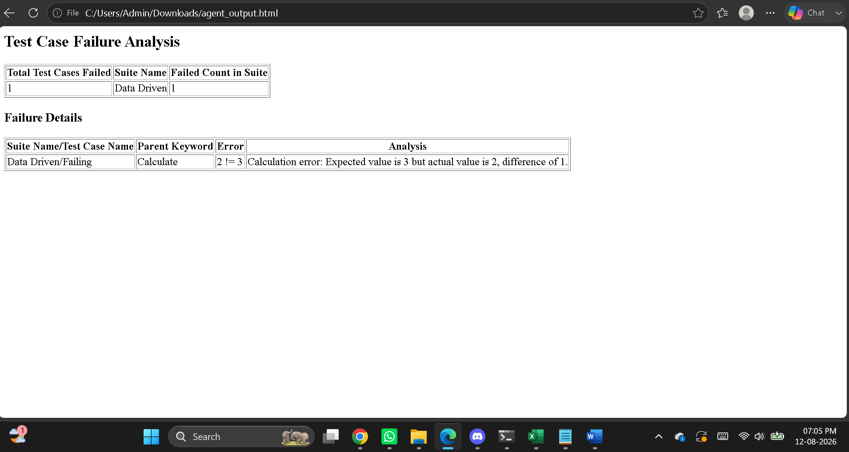

In future, If my organization agrees, I will implement this in local. Or I will integrate directly with the CI/CD Jenkins pipeline to directly analyze the log.html from the Batch and send the AI analysis along with the Jenkins email.

Below is the sample code for integrating n8n with CI/CD pipeline
Architectural Overview
[ Jenkins Workspace ] ──(1. cURL Upload)──> [ n8n Webhook Trigger ]
│
[ Jenkins Workspace ] <──(3. Write File)──── [ n8n AI Agent / LLM Node ]
- Trigger & Upload: Jenkins executes a shell command (using curl) to send files from its workspace directly to an n8n Webhook. [1, 2]
- AI Processing: n8n reads the binary file, extracts its contents, feeds it to an LLM provider (like OpenAI or Anthropic), and instructs the model to create a response. [1, 2]
- Delivery: n8n saves the AI output as a new file and transmits it back to the Jenkins workspace (either via the Webhook response or by utilizing the Jenkins API).

Step-by-Step Implementation
1. Configure the n8n Workflow [1]
To accept files and process them with AI, structure your n8n workflow using these sequential nodes:
- Webhook Trigger Node: Set the HTTP Method to POST and change the Response Mode to responseNode. In the node options, ensure Binary Data is enabled so n8n accepts multi-part file uploads. [1, 2, 3, 4, 5]
- Extract From File Node (Optional): If you are uploading text-based files (like .txt, .json, .md, or .csv), use this node to read the binary data and convert it into a string variable. [1]
- AI Agent / Advanced AI Node: Connect an OpenAI or Anthropic model node. Use a prompt like: "Analyze the attached file content and provide a summary formatted exactly as markdown." Feed the string or binary object directly into this node. [1, 2, 3, 4, 5]
- Convert to File Node (Optional): Take the text response generated by the AI model and convert it back into a binary file object (e.g., naming it ai_response.json). [1]
- Respond to Webhook Node: Map this node to pass the newly created binary file back as the direct payload of the original HTTP connection.
2. Configure the Jenkins Pipeline [1]
In your Jenkinsfile or pipeline build step, use a shell script block to extract the file from the workspace, upload it to n8n, and download the returned AI file.

groovy
pipeline {
agent any
stages {
stage('Process File with AI') {
steps {
script {
// Send workspace file to n8n and save the AI response directly back to workspace
sh '''
curl -X POST "https://your-n8n-instance.com" \
-F "file=@${WORKSPACE}/source_data.txt" \
-o "${WORKSPACE}/ai_analysis_result.md"
'''
}
}
}
stage('Next CI/CD Steps') {
steps {
// Verify the file was created and use it in your build
sh 'cat ${WORKSPACE}/ai_analysis_result.md'
}
}
}
}

Alternative Delivery Methods
If your AI processing pipeline takes a long time and risks causing a Jenkins gateway timeout, switch from a synchronous webhook to an asynchronous pattern:
- Jenkins API Node: Instead of responding immediately to the webhook, let Jenkins continue its build path. When n8n finishes generating the AI response, it can call the Jenkins API via the n8n Jenkins node to trigger a follow-up job, passing the AI response string or file URL as a build parameter. [1, 2, 3]
- SSH / Git Commit Push: Use n8n's GitHub / GitLab node to commit the generated AI file right back into the source repository repository, automatically updating the workspace on the next execution cycle. [1]

If you would like to map this out further, please let me know:
- What format are the input files (e.g., code logs, CSVs, text documents)?
- Which AI model or LLM vendor (OpenAI, Claude, local model) do you plan to use?
- Does your n8n instance reside on the same network as your Jenkins server, or is it cloud-hosted?

